**Title: Potential gains in life expectancy by reducing lifespan inequality in Denmark**

**Authors:** José Manuel Aburto a*, Maarten Wensink a*, James W. Vaupel a & Rune Lindahl-Jacobsen a

**Author affiliations:**

a Max-Planck Odense Center on the Biodemography of Aging, Department of Public Health- Epidemiology, Biostatistics and Biodemography, University of Southern Denmark, Odense 5000, Denmark.

* These authors contributed equally to the paper

**Corresponding authors:** José Manuel Aburto & Maarten Wensink

**Classification:** Epidemiology, Public Health, Demography

**Keywords:** Demography, lifespan variability, aging, mortality, cause of death

**Abstract [250 words]**

***Background*** Increasing life expectancy and lifespan equality are important policy goals. Danish female life expectancy stagnated between 1975 and 1995, and life expectancy in Denmark still lags that in Sweden for both sexes. It is unknown how lifespan inequality changed, driven by which causes.

***Methods*** We made cause-by-age decompositions of the changes in Danish life expectancy and lifespan inequality from 1960 to 2014, and of current Swedish-Danish differences.

***Results*** Stagnation in Danish female life expectancy coincided with a shorter period of stagnation in lifespan inequality (1975-1990). The stagnation in female lifespan between 1975 and 1995 was mainly driven by increases in cancer and non-infectious respiratory mortality offsetting a reduction in cardiovascular and infant mortality. Female life disparity in the years 1975-1990 stagnated because a reduction in infant mortality was offset by an increase in mid-age smoking-related cancer and non-infectious respiratory diseases, accompanied by a reduction in old-age-cardiovascular mortality. After 1995 life expectancy and lifespan equality increased in lockstep, but still lag those of Sweden mainly to infant mortality and cancer.

***Conclusions*** In Denmark since 1960, changes in life expectancy and lifespan inequality were largely driven by the same causes, suggesting important social issues, but also a clear policy target. The comparison with Sweden suggests that Denmark can now reduce life disparity and increase life expectancy through the same policy targets: cancer and infant mortality.

**Introduction**

Life expectancy is an important metric of the health status of a population and the performance of the healthcare system (1). It affects individual decisions, such as when to retire. Another important dimension is the uncertainty around that expectation: lifespan inequality (2). Lifespan inequality has become relevant for policy makers with the growing interest in economic and health inequalities (3, 4), in particular because lifespan inequality is often negatively associated with life expectancy (5-7). Typically, early deaths are more common in underprivileged groups, simultaneously reducing life expectancy and increasing lifespan inequality (8-10). Also, individuals may decide when to invest in education or when to retire based on the uncertainty surrounding their eventual time of death (10).

Life expectancy is lower in Denmark than in Norway and Sweden. While their Scandinavian counterparts showed continuous improvement, life expectancy stagnated among Danish women between the mid-1970s and mid-1990s, to improve thereafter, remaining lower than in Sweden and Norway. The stagnation in life expectancy resulted mainly from increased mortality of those born in 1919-1939, among which smoking throughout life was more prevalent, and alcohol consumption was also higher (11, 12). It is unknown how lifespan inequality developed since 1960 and which causes of death drove those changes.

Here we test the hypotheses that 1) Denmark has higher lifespan inequality relative to Sweden and Norway; 2) the stagnation in life expectancy of Danish women was accompanied by a stagnation in lifespan inequality; and 3) this stagnation in lifespan inequality was driven by smoking related causes, such as cancers and respiratory illnesses. In addition, we address the questions: What should Denmark do now to reduce lifespan inequality, and how would that translate into gains in life expectancy towards Swedish levels?

**Data and Methods**

***Mortality and cause of death data***

Period lifetables with one-year age intervals were retrieved from the Human Mortality Database (13) for Denmark, Sweden and Norway from 1960 to 2014. These data contain high quality information on lifetable measures, such as the death distribution, survival function and life expectancy, by age and sex. We used cause-of-death data from the WHO Mortality Database to compute the proportion of deaths by cause, age, and sex in a given year for the same period (14). These are available in 5-year age and period categories. Ungrouping into 1-year groups increases the accuracy of the resulting estimates (15). Thus, we ungrouped the cause-of-death data into single-year ages using efficient estimation of smooth distributions and applied the proportions in the single-age lifetables (16).

***Cause-of-death classification***

Data on causes of death were classified using the seventh, eighth, ninth and tenth revisions of the International Classification of Diseases (ICD) during the period studied. Deaths were grouped in seven major cause-of-death categories aiming at better capturing conditions that might have affected mortality in these countries. We considered that smoking prevalence was comparatively high among women (and still remains a problem) in Denmark; that the cardiovascular revolution took place during the studied period; and that the management of infectious diseases has improved greatly over the past half century. Hence, we grouped causes of death as follows: 1) Cancers sensitive to smoking, 2) Cancers not sensitive to smoking, 3) Cardiovascular diseases, 4) Non-infectious respiratory diseases, 5) Infectious respiratory diseases, 6) External causes and 7) Rest of causes. For ICD codes and details on the classification see Supplemental Information. Causes of death above age 85 were not decomposed, because of low reliability. Our coding was cross-checked with other coding across ICD versions in the literature (17). A sensitivity analysis was performed to assure consistency of grouping across ICD versions (see SI).

***Lifespan inequality measure***

Several dispersion measures have been proposed to analyze lifespan inequality (18). Here, we use the coefficient of variation (CoV), which is the standard deviation divided by the mean of the lifetable age-at-death distribution, i.e. life expectancy (see SI for a brief description). CoV has been found to be a good indicator to measure lifespan inequality (19). The strong correlation between dispersion indicators suggests that main conclusions and results would not differ regardless of the measure used (18, 20, 21). Lifespan and life disparity (CoV) were calculated for Denmark, Norway and Sweden throughout 1960-2014.

***Decomposition techniques***

We made age-by-cause decompositions of the changes in lifespan and lifespan inequality in Denmark, Norway and Sweden from 1960 to 2014 using standard decomposition techniques (22). These decompositions allow singling out any period during those years, for instance 1975-1995[1]. We quantified the age-and-cause contributions to the current differences in life expectancy and life disparity between Denmark and Sweden.

**Results**

***Trends in lifespan inequality and life expectancy 1960-2014***

The stagnation in life expectancy for Danish females was accompanied by a shorter stagnation in life disparity (Figure 1A). Swedish and Norwegian females experienced a monotonous decrease in disparity and increase in life expectancy throughout the period (Figure 1A). For males in all three countries, life expectancy increase was slow in 1960-1980, but accelerated thereafter, while the decrease in life disparity was more monotonous (Figure 1B).

[Figure 1 about here]

***Decomposition of changes in life expectancy and lifespan inequality for Denmark***

Figure 2 shows the age-by-cause decomposition of life expectancy (panel A) and lifespan inequality (Panel B) for three periods 1960-1975, 1975-1995, 1995-2014. Positive (negative) values increase (decrease) life expectancy or lifespan inequality.

Between 1960 and 1975, Danish female life expectancy increased from 74 to 77 years mainly due to a reduction in infant mortality and mid- and old-age cardiovascular mortality. For males1, infant mortality was also reduced, but the contribution from cardiovascular diseases was absent. For both sexes, lifespan inequality was reduced mainly because of the reduction in infant mortality.

Between 1975 and 1995, Danish female life expectancy stagnated at about 77 years because a continued reduction in infant mortality and old-age cardiovascular mortality was offset by an increase in (mainly smoking-related) cancer and non-infectious respiratory mortality between ages 55 and 85. Also, reduction in cardiovascular mortality was lower in Danish females relative to Danish males and Swedish females (available [online](https://goo.gl/9dLNrH)). Non-smoking related cancer contributed negatively to lifespan for both females and males, which was the main offsetting cause of death for males, that otherwise experienced increases in lifespan due to a reduction in infant mortality and mid- and high-age cardiovascular mortality.

Improvement in lifespan inequality was low for Danish females between 1975 and 1995 because the reduction due to infant mortality was offset by an increase in mid-age smoking related cancer and non-infectious respiratory diseases, and a reduction in old-age cardiovascular mortality. For males, the reduction in life disparity was larger than for females, mainly driven by a reduction in infant mortality and early-life external mortality.

Between 1995 and 2014, Danish female life expectancy increased from 77.8 to 82.7 years due to almost all causes at all ages, in particular cardiovascular mortality. Also for males, all causes at all ages provided positively to lifespan development (from 72.7 to 78.6). As for disparity, for both sexes all ages and all causes up to life expectancy reduced inequality, while a reduction in cardiovascular mortality at ages higher than life expectancy increased inequality.

[Figure 2 about here]

***Decomposition of current differences in life expectancy and lifespan inequality with Sweden***

Currently (2014)[2], life expectancy is higher in Sweden than in Denmark for both sexes due to almost all causes at all ages, with the major exception of external mortality being higher in Sweden than in Denmark at all ages, in particular ages 15-35. Two major classes of mortality where Denmark is doing worse than Sweden could be identified. First, infant mortality is higher in Denmark than in Sweden (by a factor two). Second, mid- and old-age cancer mortality is higher in Denmark than in Sweden. Other recent years showed the same pattern.

For lifespan inequality, the same holds: infant mortality and mid-life cancer mortality increase Denmark’s disadvantage relative to Sweden, somewhat offset by lower external mortality between ages 15 and 35. However, as may be expected considering the ages relative to life expectancy where each contribution is made, Denmark’s *life expectancy* disadvantage relative to Sweden is mainly due to mid- and high-age *cancer mortality*, while Denmark’s *lifespan inequality disadvantage* is mainly due to higher *infant mortality*.

[Figure 3 about here]

***Potential gains in Danish life expectancy if lifespan inequality were reduced towards Swedish levels***

Table 1 presents how much life expectancy in Denmark would increase by a reduction in the gap with Swedish lifespan inequality for both sexes in 2014 for each cause of death. Reducing mortality from cancers below age 85 would decrease the gap in lifespan inequality by 31.1% and 21.8% for females and males, respectively. This would be translated into more than half a year gains in life expectancy for both sexes (0.57 for females and 0.66 years for males). Similarly, achieving Swedish levels in cardiovascular conditions would decrease the gap in lifespan inequality by almost 10% in both sexes and increase life expectancy by .2 year. Conversely, if Sweden were to achieve the level of Danish external mortality, it would benefit by two additional months in life expectancy for both sexes.

[Table 1 about here]

**Discussion**

***Potential limitations***

As any cause of death analysis, our study has the limitations that: 1) causes of death are treated as mutually exclusive, while they may not be (e.g., poor sight due to diabetes may lead to an accident); 2) medical doctors and even coroners have imperfect knowledge about causes of death; and 3) trends in awareness of certain diseases, and changing insights in disease processes affect classification. For instance, with increasing knowledge and awareness of the effect of immobilization and hospitalization on the chance of pneumonia, pneumonia became increasingly classified as secondary to some principle cause of death (ref). In particular causes of death at old-age should be discounted, because co-morbidity is rampant, so that various causes may contribute to death, leading some to suggest that ‘old age’ is a valid cause of death after all. Yet through using otherwise high quality data and broad categories of causes of death, we believe we have achieved a useful, workable grouping of causes of death.

***Implications***

Reducing lifespan inequality cannot be the only policy goal, since this would neglect the interests of those who have already lived to ages close to or exceeding lifespan: Mortality reductions at ages below life expectancy decrease lifespan inequality, but mortality reductions at ages above life expectancy increase lifespan inequality (23).

The causes that extend lifespan and the causes that reduce inequality are not necessarily the same (24). In Denmark, however, they have been, and still are, remarkably consistent. Causes of death related to smoking and alcohol consumption have contributed to the practically simultaneous stagnation in life expectancy and lifespan inequality in the years 1975-1995, reducing life expectancy and increasing lifespan inequality at the same time. These results suggest that without smoking related mortality, the Danish population would have experienced compression in mortality. Previous evidence suggests that this needs not to be the case among the Finnish population (25).

After 1995, Denmark has been able to reduce inequality in lifespans in lockstep with increases with life expectancy. This has been possible because of major improvements, mainly below age 80, in cancer and cardiovascular diseases. However, it is possible that this progress may have been different by socioeconomic status (8). Moreover, there still is room for improvement, since Denmark lags Sweden in both life expectancy and lifespan inequality. The comparison with Sweden suggests that Denmark can simultaneous increase life expectancy and decrease lifespan inequality by targeting two main causes of death: cancer and infant mortality. Reducing lifespan inequality towards Sweden by these conditions would lead to an increase of 0.7 and 0.8 years in life expectancy for females and males in Denmark, respectively. To put this in perspective, in 2014 the mortality rate in the first year of life in Denmark is twice as high as in Sweden, which is one of the lowest in developed countries (13). Thus, infant mortality is the largest single contributor to the gap with Sweden in terms of lifespan inequality. Preventive policies focusing on prenatal risk factors and improving maternal health before and during pregnancy (26), as well as efforts to reduce the risk of sudden infant death syndrome (27) could help reducing infant mortality towards Swedish levels.

Targeting cancer is another clear public health intervention to reduce lifespan inequality and increase life expectancy in Denmark. Our results show that improvements in mortality from cancer have had an effect on both health indicators in the last 20 years. However, Denmark had the highest mortality rates from all neoplasms in the European region, and the female population exhibited the highest lung cancer mortality rates (28). This is in line with our comparison with Sweden and with previous evidence highlighting the role of smoking behaviors on life expectancy trends (12).

For Sweden, the data suggest that young-age external mortality can be further reduced. Of course, a difference alone does not mean that it is easy to achieve a reduction. Sweden may be different from Denmark geographically. There are more rural areas, which may make it harder to reduce accidents. Still, it is an option worth considering.

For other countries that lag a comparable country, similar decompositions can be made. This may not result in a clear and consistent message: causes of death that hold back life expectancy may not be the same as the causes of death that hold back equality. Yet if it does, as in the case of Denmark, the benefits are substantial, because the policy goal becomes so clear. We therefore suggest that our method could be a valuable new tool for epidemiologists and policy makers alike.

**Conclusions**

1) The stagnation in Danish female life expectancy was accompanied by a stagnation in lifespan inequality, driven largely by the same, smoking related causes.

2) Currently, Denmark lags Sweden in terms of high life expectancy and low inequality due to two main causes: infant mortality and cancer.

3) Denmark therefore has a clear and consistent public health policy target: reduce infant mortality and cancer mortality.

4) Our approach demonstrates how policy targets can be identified that increase life expectancy through a reduction in lifespan inequality.

5) If similar results hold for other countries too, this would be highly interesting, because the policy recommendations that follow are so clear and consistent.

**Figures and Tables**

Figure 1. Life expectancy (panel A) and lifespan inequality (panel B) trends from 1960 to 2015 for Denmark, Sweden and Norway by sex. The shaded area refers to the period of life expectancy stagnation in Danish females 1975-1995.

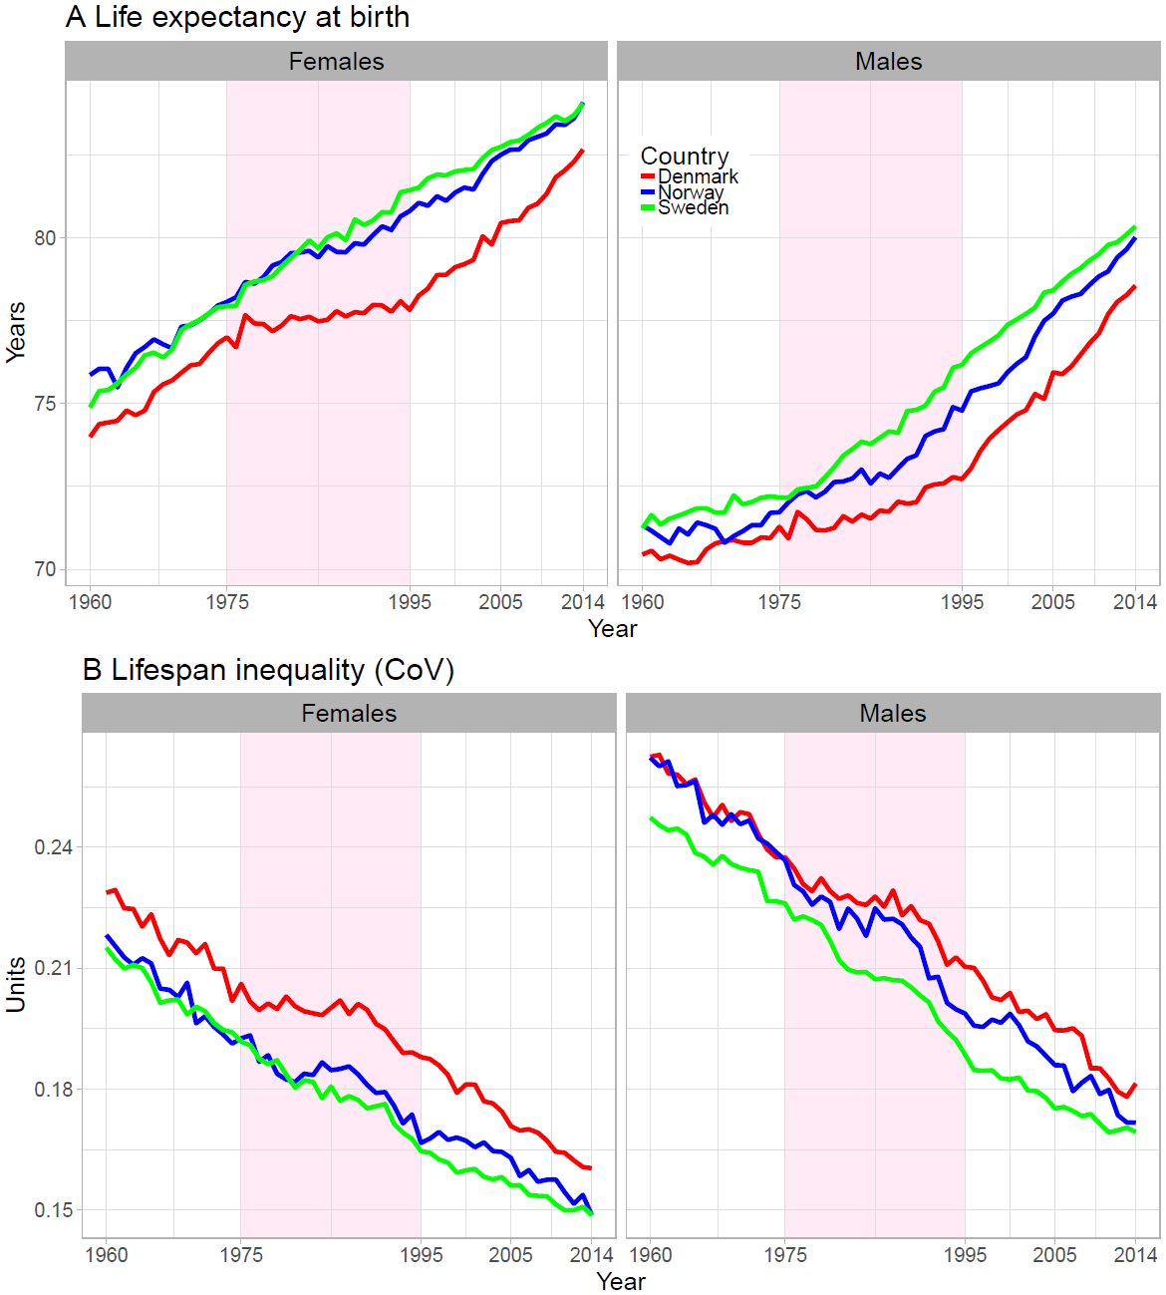

Figure 2. Age and cause contributions to changes in life expectancy (panel A) and lifespan inequality (panel B) between 1960-1975, 1975-1995 and 1995-2014 for Danish females. The age-specific causes of death that contribute to the increase in the Danish life expectancy are shown in the right-hand side (zero) vertical axis, and the causes of death that oppose this trend are in the left. Note: Age 0 is truncated in panel B since it accounts for the largest contribution.

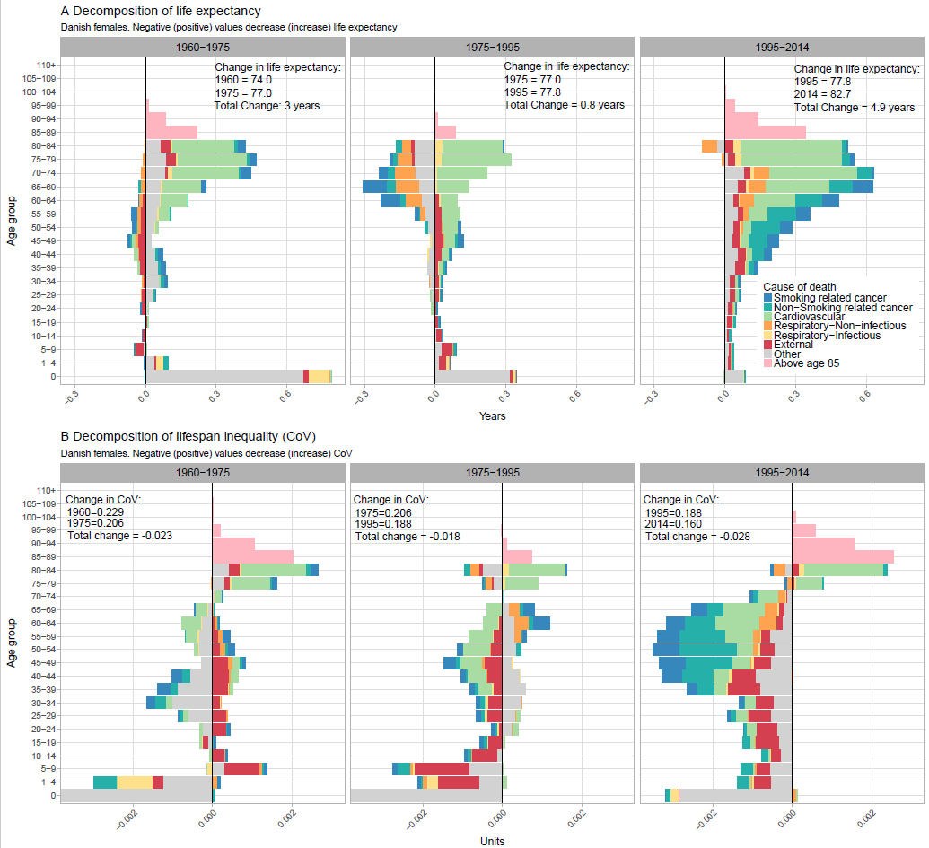

Figure 3. Age and cause contributions to the gap in life expectancy (Panel A) and lifespan inequality (Panel B) with Sweden in 2014 by sex.

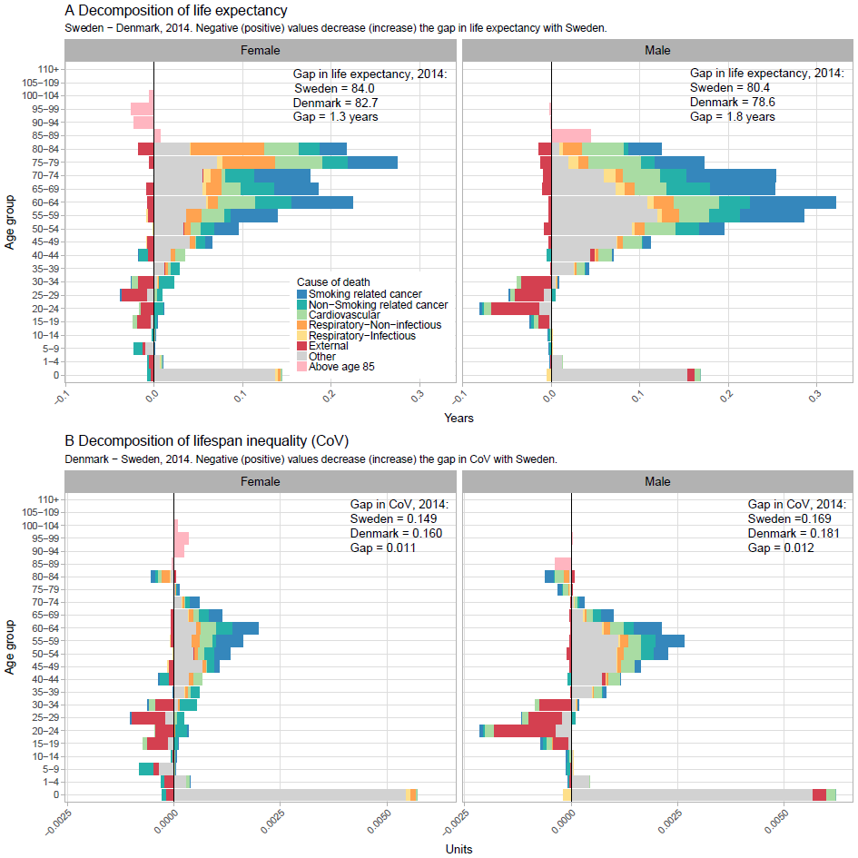

Table 1. Potential gains in life expectancy in Denmark if inequality is reduced (%) to Swedish levels in 2014 for each cause of death.

|  |  |  |  |  |  |
| --- | --- | --- | --- | --- | --- |
| Sex |  | Cause of death | Reduce gap with Sweden in CoV (%) |  | Potential Gains in life expectancy (years) |
| Females | 1 | Smoking related cancer | 18.12% |  | 0.35 |
|  | 2 | Non-Smoking related cancer | 12.99% |  | 0.22 |
|  | 3 | Cardiovascular | 9.88% |  | 0.21 |
|  | 4 | Respiratory-Non-infectious | 6.85% |  | 0.23 |
| wa | 5 | Respiratory-Infectious | 2.25% |  | 0.03 |
|  | 6 | External | -26.39% | * | -0.15 |
|  | 7 | Other | 70.89% |  | 0.55 |
|  | 8 | Above age 85 | 5.41% |  | -0.05 |
|  |  |  |  |  |  |
| Males | 1 | Smoking related cancer | 15.25% |  | 0.47 |
|  | 2 | Non-Smoking related cancer | 6.54% |  | 0.19 |
|  | 3 | Cardiovascular | 10.17% |  | 0.33 |
|  | 4 | Respiratory-Non-infectious | 4.51% |  | 0.12 |
|  | 5 | Respiratory-Infectious | 0.74% |  | 0.05 |
|  | 6 | External | -26.46% | * | -0.19 |
|  | 7 | Other | 92.11% |  | 0.77 |
|  | 8 | Above age 85 | -2.86% | * | 0.04 |
| * Reduces the gap with Sweden. Represents potential gains for Sweden. | | | | | |

**References**

1. Organization WH. World Health Statistics 2016: Monitoring Health for the SDGs Sustainable Development Goals: World Health Organization; 2016.

2. Tuljapurkar S. The final inequality. Demography and the Economy. 2011:209.

3. Marmot M. Inequalities in health. New England Journal of Medicine. 2001;345(2):134-5.

4. Mackenbach JP, Kulhánová I, Artnik B, Bopp M, Borrell C, Clemens T, et al. Changes in mortality inequalities over two decades: register based study of European countries. bmj. 2016;353:i1732.

5. Vaupel JW, Zhang Z, van Raalte AA. Life expectancy and disparity: an international comparison of life table data. BMJ open. 2011;1(1):e000128.

6. Edwards RD, Tuljapurkar S. Inequality in life spans and a new perspective on mortality convergence across industrialized countries. Population and Development Review. 2005;31(4):645-74.

7. Smits J, Monden C. Length of life inequality around the globe. Social Science & Medicine. 2009;68(6):1114-23.

8. Brønnum-Hansen H. Socially disparate trends in lifespan variation: a trend study on income and mortality based on nationwide Danish register data. BMJ open. 2017;7(5):e014489.

9. Firebaugh G, Acciai F, Noah AJ, Prather C, Nau C. Why lifespans are more variable among blacks than among whites in the United States. Demography. 2014;51(6):2025-45.

10. van Raalte AA, Kunst AE, Deboosere P, Leinsalu M, Lundberg O, Martikainen P, et al. More variation in lifespan in lower educated groups: evidence from 10 European countries. International Journal of Epidemiology. 2011:dyr146.

11. Lindahl-Jacobsen R, Oeppen J, Rizzi S, Möller S, Zarulli V, Christensen K, et al. Why did Danish women’s life expectancy stagnate? The influence of interwar generations’ smoking behaviour. European Journal of Epidemiology. 2016:1-5.

12. Lindahl-Jacobsen R, Rau R, Jeune B, Canudas-Romo V, Lenart A, Christensen K, et al. Rise, stagnation, and rise of Danish women’s life expectancy. Proceedings of the National Academy of Sciences. 2016;113(15):4015-20.

13. Human Mortality Database. University of California BU, and Max Planck Institute for Demographic Research (Germany). Human Mortality Database. 2017.

14. Organization WH. Health statistics and information systems 2017 [Available from: <http://www.who.int/healthinfo/mortality_data/en/>.

15. Rizzi S, Thinggaard M, Engholm G, Christensen N, Johannesen TB, Vaupel JW, et al. Comparison of non-parametric methods for ungrouping coarsely aggregated data. BMC medical research methodology. 2016;16(1):59.

16. Rizzi S, Gampe J, Eilers PH. Efficient estimation of smooth distributions from coarsely grouped data. American journal of epidemiology. 2015;182(2):138-47.

17. Janssen F, Kunst AE. ICD coding changes and discontinuities in trends in cause-specific mortality in six European countries, 1950-99. Bulletin of the World Health Organization. 2004;82(12):904-13.

18. van Raalte AA, Caswell H. Perturbation analysis of indices of lifespan variability. Demography. 2013;50(5):1615-40.

19. Wrycza TF, Missov TI, Baudisch A. Quantifying the shape of aging. PloS one. 2015;10(3):e0119163.

20. Wilmoth JR, Horiuchi S. Rectangularization revisited: Variability of age at death within human populations*. Demography. 1999;36(4):475-95.

21. Colchero F, Rau R, Jones OR, Barthold JA, Conde DA, Lenart A, et al. The emergence of longevous populations. Proceedings of the National Academy of Sciences. 2016.

22. Horiuchi S, Wilmoth JR, Pletcher SD. A decomposition method based on a model of continuous change. Demography. 2008;45(4):785-801.

23. Gillespie DO, Trotter MV, Tuljapurkar SD. Divergence in age patterns of mortality change drives international divergence in lifespan inequality. Demography. 2014;51(3):1003-17.

24. Seligman B, Greenberg G, Tuljapurkar S. Equity and length of lifespan are not the same. Proceedings of the National Academy of Sciences. 2016;113(30):8420-3.

25. van Raalte AA, Myrskylä M, Martikainen P. The role of smoking on mortality compression: An analysis of Finnish occupational social classes, 1971-2010. Demographic Research. 2015;32:589.

26. Zylbersztejn A, Gilbert R, Hardelid P, Hjern A. Why do more infants die in the UK than in Sweden? An intercountry comparison of birthweight-specific infant mortality. The Lancet. 2015;386:S83.

27. Wennergren G, Nordstrand K, Alm B, Möllborg P, Öhman A, Berlin A, et al. Updated Swedish advice on reducing the risk of sudden infant death syndrome. Acta Paediatrica. 2015;104(5):444-8.

28. Hashim D, Boffetta P, La Vecchia C, Rota M, Bertuccio P, Malvezzi M, et al. The global decrease in cancer mortality: trends and disparities. Annals of Oncology. 2016;27(5):926-33.

1. We have created an interactive app where the reader can analyze any period he/she might be interested in for any sex. Available [online](https://goo.gl/9dLNrH).
2. Results for any year from 1960-2014 and for Norway vs Sweden available [online](https://goo.gl/9dLNrH).